# A

# PROJECT REPORT

# ON

# “SCREEN SHOT HACKER”



# SUBMITTED BY

# S.AJAY (160116737302).

# D.SURAJ (160116737304).

# G.MACHENDAR (160116737306).

# SUBMITTED TO

# Mr. P. SRINIVAS RAO, ASSISTANT PROFESSOR

# “INFORMATION TECHNOLOGY”

# 2017-18



**Chaitanya Bharathi Institute of Technology Gandipet,Hyderabad 500075**

**Certificate**

This is the certificate that the project entitled “SCREEN SHOT HACKER”

is prepared under guidance and supervision by:

Name Roll No

**1. S.AJAY 160116737302**

**2. G.MACHENDAR 160116737306**

**3. D.SURAJ 160116737304**

**B.E 2/4 INFORMATION TECHNOLOGY DEPARTMENT**

**2017-2018**

Submitted to **Mr.P.Srinivas Rao, Assistance Professor.**

Signature Of

**Internal Examiner External Examiner**

**Acknowledgment**

I wish to express my healthy gratitude to **Dr.P.RAVINDER REDDY** Principal Secretary and Correspondent of **CHAITANYA BHARATI INSTITUTE OF TECHNOLOGY,GANDIPET.** For providing all the facilities required for the seminar presentation.

We wish to take this opportunity to express our sincere thanks to **Dr.SURESH PABBOJU** Head of the Department for the interest technical support and suggestions during the seminar leading to our success.

We are obliged and grateful to my guide MR.**P.SRINIVAS RAO** lecturer of **INFORMATION TECHNOLOGY**  Department for his valuable suggestions and sagacious guidance in all aspects during the technical of our training.

We hereby express my sincere thanks regards to all teaching staff, parents and friends who extend their help hand in the accomplished of the project.

**Abstract**

In the present scenario, there may be situation where the Manager of a company wants to check his employee’s status frequently in some time intervals. So in that situation, it may not be that feasible if the manager goes frequently to the employee and checks the status of that employee and this makes the employee to feel uneasy about his manager. Evaluating this scenario, we are trying to develop a Desktop Application where the screen shot of the system is taken frequently in the given time interval and mailed it to the specified mailed address. In this scenario, the manager may not find it difficult to go to the employees each and every time and make the employee feel uneasy about him.

The problem with the previous scenario we try to overcome the problem to

simple i.e., the system screen of employee’s can be captured and send to the manager with that it can be reduce the time and security for the company.

**Contents**

* Abstract 4
* Introduction 6
* Software and Hardware requirements and specifications 13
* Implementation 14
* Results 15
* Conclusion and Future scope 22
* Reference / Bibliography 23
* Conclusion and Future scope

**INTRODUCTION**

## Project Features:

* This application is Useful for Manager
* Cause to change the Employee attitude.
* Reduced company time on spending
* And also avoid conflict between employee and Manager

## SCOPE OF PROJECT

This product is mainly indented to the company people in order to maintain employee work related screenshot automatically passed to manager,this is useful for Manager of the company.

Evaluating this scenario, we are trying to develop a Desktop Application where the screen shot of the system is taken frequently in the given time interval and mailed it to the specified mailed address. In this scenario, the manager may not find it difficult to go to the employees each and every time and make the employee feel uneasy about him.

**Architecture :**

Screenshot Hacker application will follow 2-Tire Architecture, as the presentation and business logic will be in one layer and the database interaction will be in other layer. SQL Server2008 is used as backend storage and ASP.NET is used for presentation layer. C#.NET is used to write the entire application code.

**Business Need:**

This can be used in the small or big organizations enterprises where the managers can view the information by getting the screenshot of employees desktop for the time interval.

**Technologies Used :**

We have used Microsoft’s .NET Technologies: ASP.NET 2.0, C#.NET 2.0, AJAX Extensions (version for .NET 2010). For database, SQL server2008 is taken as backend.

**Advantages:**

* Company management can know the employee work status by

Capturing the image of his desktop.

* Manager no need to check every time what is happening at employee cabin wether is he working or doing any other things means he is wasting time by chatting, watching movies, timepass etc.
* Lot of time saved due to this automatic screen capturing for the company higher authorities like manager, Managing director etc.

**PROJECT ANALISYS**

**Existing System**

If the Manager of a company wants to check his employee’s status frequently in some time intervals. So in that situation, it may not be that feasible if the manager goes frequently to the employee and checks the status of that employee and this makes the employee to feel uneasy about his manager.

**Proposed System**

In our proposed system the screen shots are taken and sent as a mail to the respective person mail id. This helps the user to look for advanced system where in the person can access the system without ones inter action considering the drawback in the existing system, we are trying to develop application where in the screen shot of the system is taken and mailed to the mail id of the user.

# Microsoft.NET Framework

The .NET Framework is a new computing platform that simplifies application development in the highly distributed environment of the Internet. The .NET Framework is designed to fulfill the following objectives:

* To provide a consistent object-oriented programming environment whether object code is stored and executed locally, executed locally but Internet-distributed, or executed remotely.
* To provide a code-execution environment that minimizes software deployment and versioning conflicts.
* To provide a code-execution environment that guarantees safe execution of code, including code created by an unknown or semi-trusted third party.
* To provide a code-execution environment that eliminates the performance problems of scripted or interpreted environments.
* To make the developer experience consistent across widely varying types of applications, such as Windows-based applications and Web-based applications.

To build all communication on industry standards to ensure that code based on the .NET Framework can integrate with any other code.

## Client Application Development

Client applications are the closest to a traditional style of application in Windows-based programming. These are the types of applications that display windows or forms on the desktop, enabling a user to perform a task. Client applications include applications such as word processors and spreadsheets, as well as custom business applications such as data-entry tools, reporting tools, and so on. Client applications usually employ windows, menus, buttons, and other GUI elements, and they likely access local resources such as the file system and peripherals such as printers.

## Server Application Development

Server-side applications in the managed world are implemented through runtime hosts. Unmanaged applications host the common language runtime, which allows your custom managed code to control the behavior of the server.

This model provides you with all the features of the common language runtime and class library while gaining the performance and scalability of the host server.

The following illustration shows a basic network schema with managed code running in different server environments. Servers such as IIS and SQL Server can perform standard operations while your application logic executes through the managed code.

The following sections will introduce you to some objects that have evolved, and some that are new. These objects are:

* **Connections**: For connection to and managing transactions against a database.
* **Commands**: For issuing SQL commands against a database.
* **DataReaders** : For reading a forward-only stream of data records from a SQL Server data source.
* **DataSets**: For storing, remoting and programming against flat data, XML data and relational data.
* **DataAdapters**: For pushing data into a **DataSet**, and reconciling data against a database.

**ADO.NET :**

1. ADO.NET is the next evolution of ADO for the .Net Framework.
2. ADO.NET was created with n-Tier, statelessness and XML in the forefront. Two new objects, the DataSet and DataAdapter, are provided for these scenarios.
3. ADO.NET can be used to get data from a stream, or to store data in a cache for updates.
4. There is a lot more information about ADO.NET in the documentation.
5. Remember, you can execute a command directly against the database in order to do inserts, updates, and deletes. You don't need to first put data into a DataSet in order to insert, update, or delete it.
6. Also, you can use a DataSet to bind to the data, move through the data, and navigate data relationships.

**SOFTWARE DESIGN**

The design phase begins with the requirements specification for the software to be developed. Design is the first step to moving from the problem domain towards the solution domain. Design is essentially the bridge between requirement specification and the final solution for satisfying the requirements. It is the most critical factor effecting the quality of the software.

The design process for software system has two levels.

1. System Design or Top level design
2. Detailed Design or Logical Design

**System Design:**

In the system design the focus on the deciding which modules are needed for the system, the specification of these modules and how these modules should be interconnected.

**Detailed Design:**

In detailed design the interconnection of the modules or how the specifications of the modules can be satisfied is decided. Some properties for a software system design are

* Verifiability
* Completeness
* Consistency
* Traceability
* Simplicity / Understandability

**Hardware and Software specifications**

This section elaborates on the functional requirements of the application. The SRS itself can be divided into module, each module having specifications. In order to carry out the project, the following hardware and software is required.

**SOFTWARE REQUIREMENTS:**

* OPERATING SYSTEM : Window XP
* Language : C#.Net
* Web technologies : ASP.NET
* Server : ISS-5.0

**HARDWARE REQUIREMENTS:**

* Processor : P4
* Speed : 633mhz
* RAM : 512
* Hard disk : 40GB
* Monitor : 17”

**IMPLEMENTATION**

Implementation is the stage of the project when the theoretical design is turned out into a working system. Thus it can be considered to be the most critical stage in achieving a successful new system and in giving the user, confidence that the new system will work and be effective. The implementation stage involves careful planning, investigation of the existing system and it’s constraints on implementation, designing of methods to achieve changeover and evaluation of changeover methods.

**MODULES:**

* **Login:**

The user has to give his details and it has to validated and redirect the user to the home page. The user can login to their company site and those who are logged in can access the system.

* **Screen Shot:**

The timer will be started and in each interval the application will take the screen shot and first saves it in a folder. The screenshot can be stored in a temporary folder in the admin block.

* **Mail Sending:**

After saving the screen shot in the folder, it is then retrieved back and it will be attached as an attachment to the mail and send it to the manager mail address.

**Result**

* **Main page:**

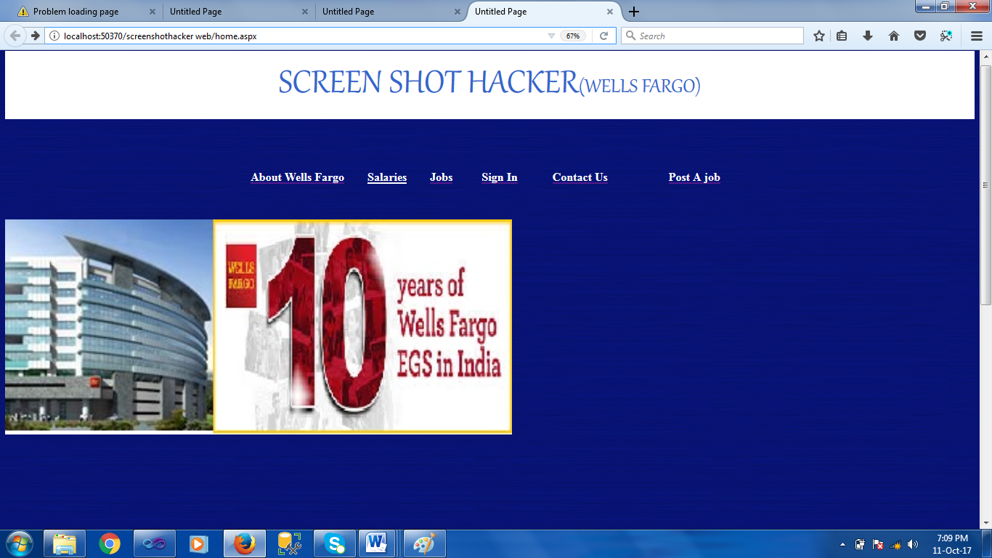

* **Sign-in page:**

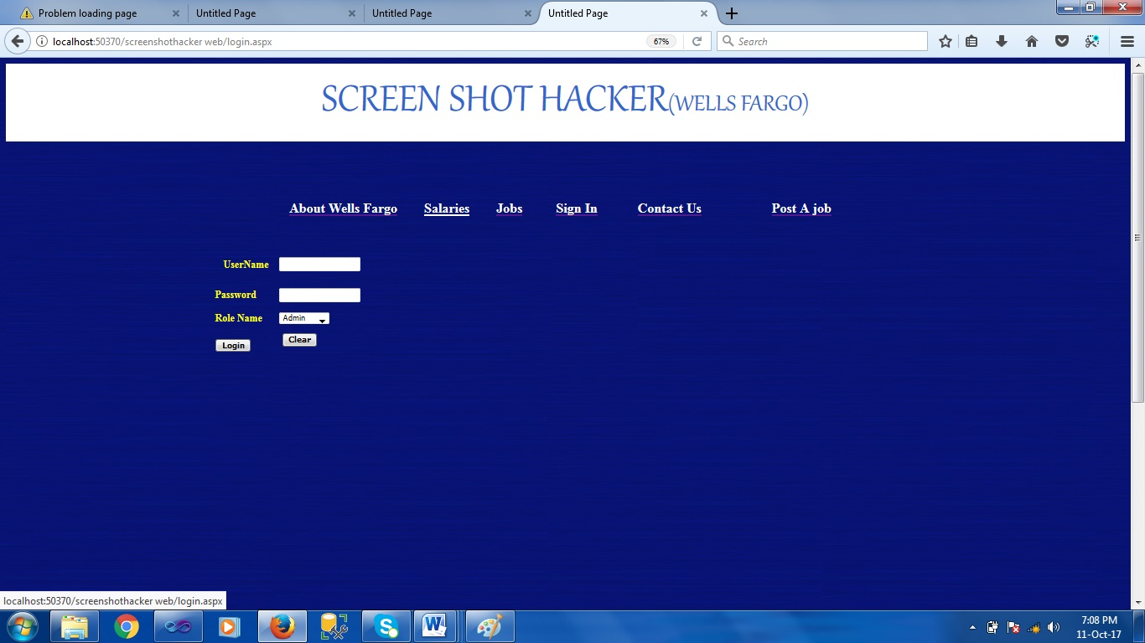

* **Admin Home page:**

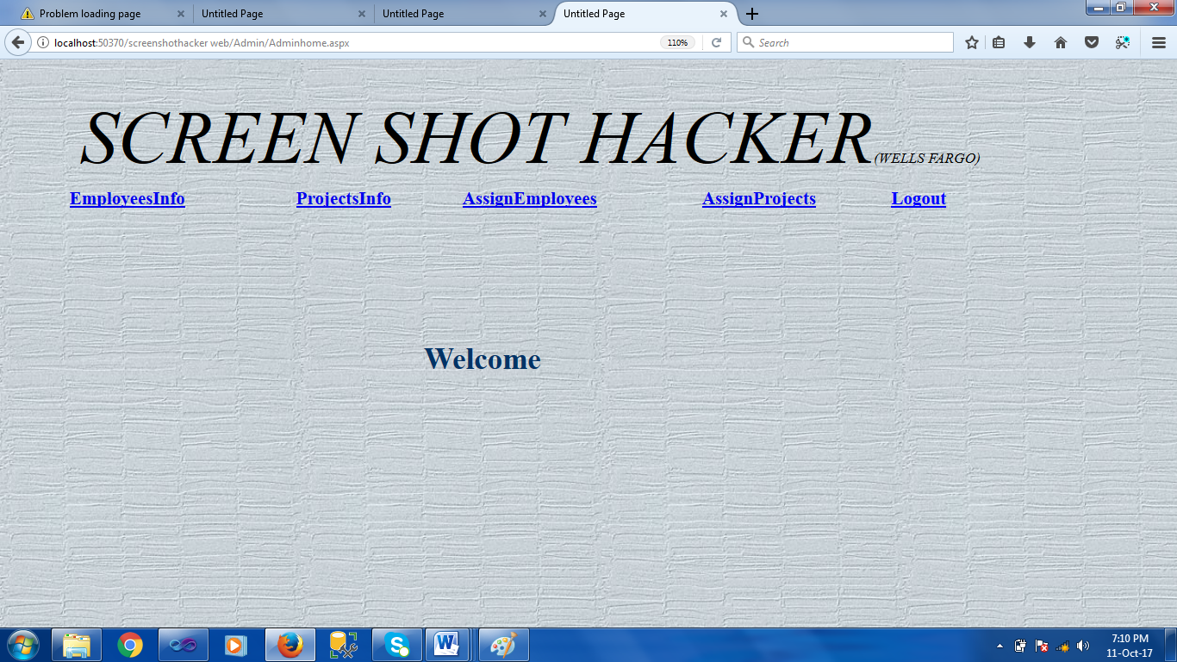

* **Manager Home page:**

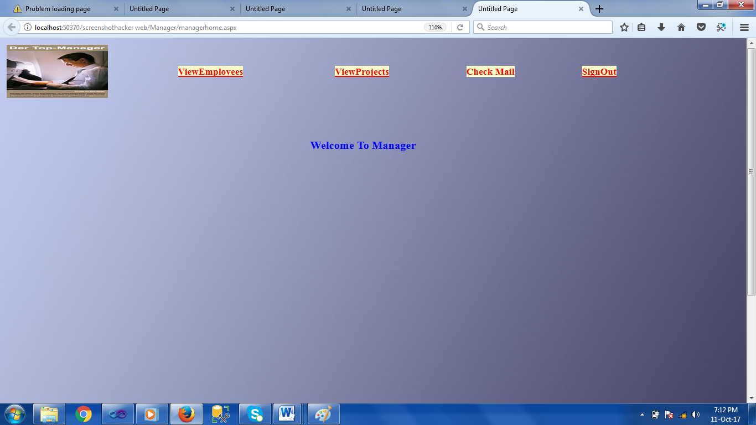

* **Employee page:**

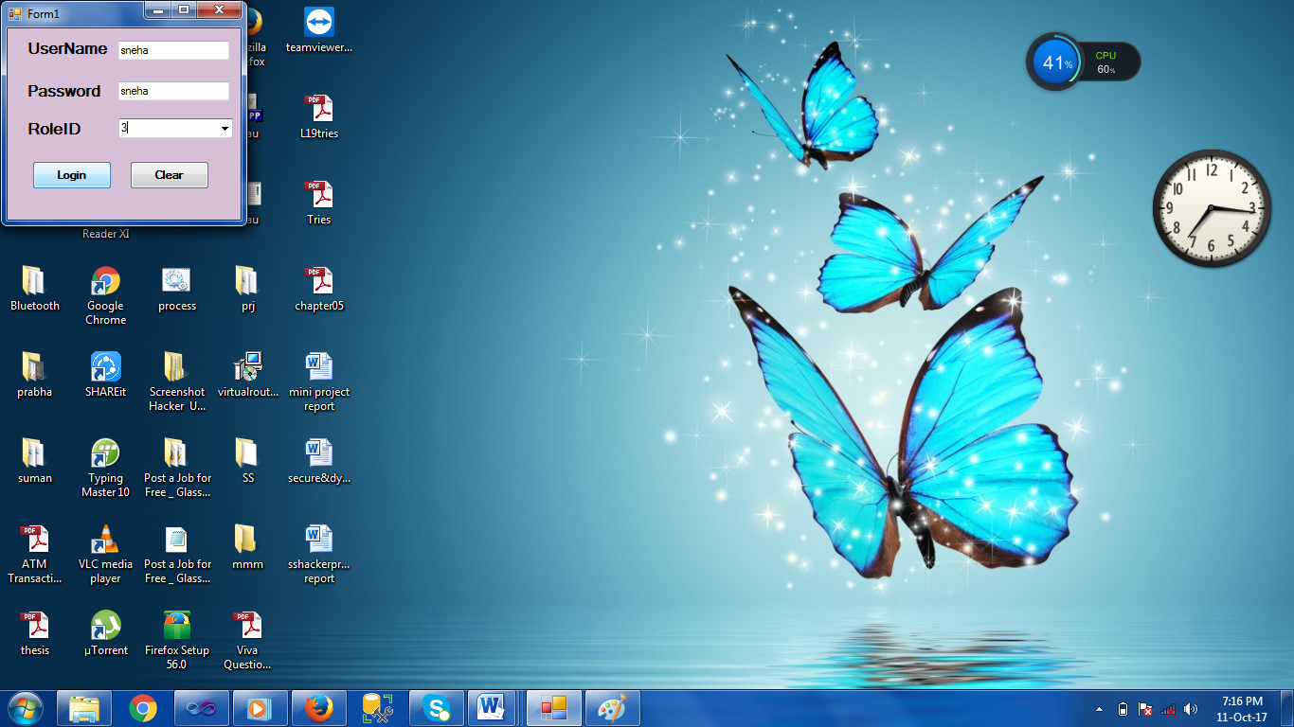

* **Output screen in Mail**

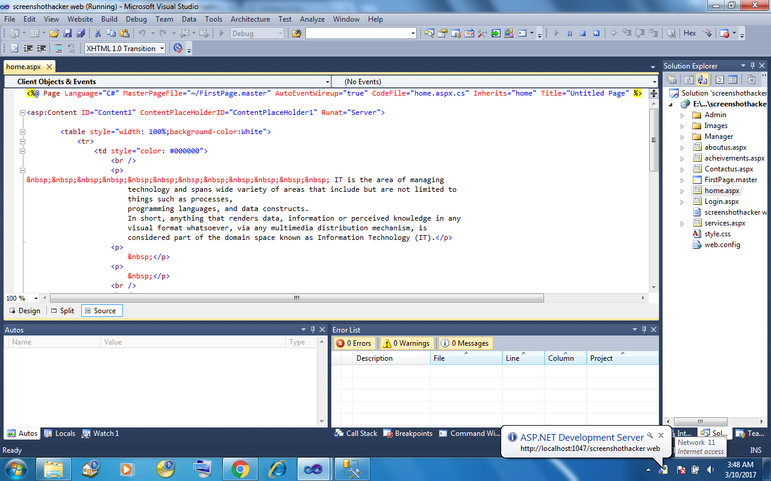

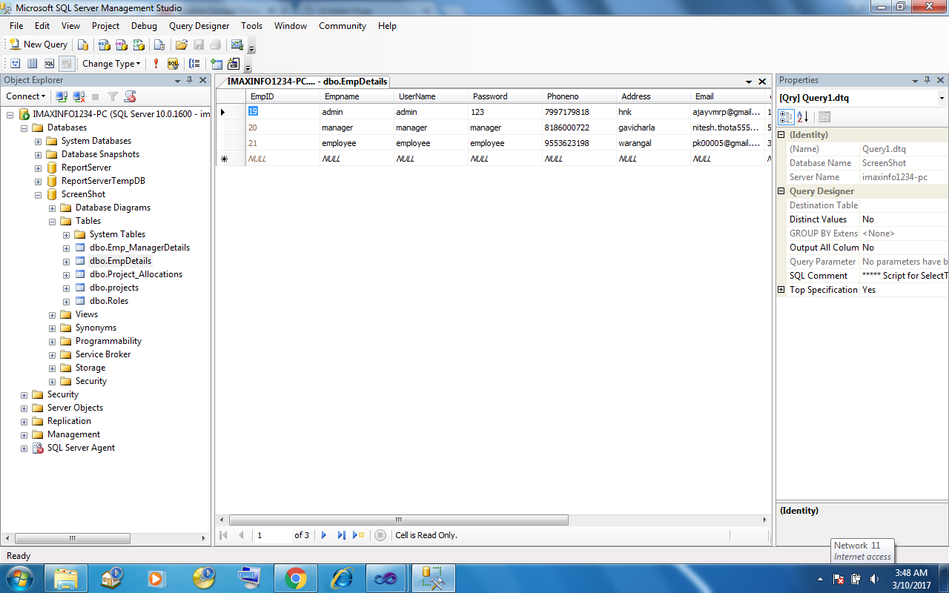

**CONCLUSION**

In this project, we all are try to reduce the work load of the manager to become smart i.e., can control from their system itself. And we are try to overcome the problem of employee guiltiness because of previously the manager can see employee’s desktop that situation is overcome by this project.

The requirements and specification are mentioned above. This project implementation is done in .NET Framework. Using C# coding we implemented a different webpages that is useful for the software companies.

We captured the screenshot of employee’s desktop and stored and send to the mail of the specified mail id.

**BIBLIOGRAPHY**

**References:**

ASP.NET 2.0 with C#-Stephen Walther

XML - XML complete reference by Aaron Skonnard & Martin Gudgin

HTML - Steven Holzner

AJAX - JavaScript and Ajax for the web, Sixth Edition(Visual Quick Start Guide)

Modern Web Design Using JavaScript and DOM by Stuart Landgridge

**Websites:**

[www.google.com](http://www.google.com)

[www.asp.net](http://www.asp.net)

[www.ajaxprojects.com](http://www.ajaxprojects.com)

[www.w3schools.com/aspnet/default.asp](http://www.w3schools.com/aspnet/default.asp)

[www.programmingtutorials.com/aspnet.aspx](http://www.programmingtutorials.com/aspnet.aspx)